## **Hands-On Activity: Applying a formula**

## Activity overview



In previous lessons, you familiarized yourself with spreadsheets and data structures. In this activity, you will work with formulas in spreadsheets.

By the time you complete this activity, you will be able to apply the SUM formula in spreadsheet software such as Google Sheets and Microsoft Excel. This will enable you to create dynamic spreadsheets, which is important for organizing and understanding data in your career as a data analyst.



### What you will need

To get started, first access the example spreadsheet of someone tracking their entertainment expenses.

To use the spreadsheet for this course item, click the link below and select Use Template.

Link to example spreadsheet: [Entertainment Expenses](https://docs.google.com/spreadsheets/d/1IJbiEEA2XIhkPctssmblodZkPWLzUgxzmjh0s1P6pv8/template/preview)

OR

If you don’t have a Google account, you can download the spreadsheet directly from the attachment below.

[Example Spreadsheet - Entertainment Expenses - Sheet1.csv](https://d3c33hcgiwev3.cloudfront.net/xA1VTx3eQrqNVU8d3kK6gA_d43b9c83af434f3d849ce2c1cef3e995_Example-Spreadsheet---Entertainment-Expenses---Sheet1.csv?Expires=1622764800&Signature=YNMyDCYQcLlbN-gxeQAMk6doDBxzxK~dqtCkkh7iMaZ4hdGzlPbez6SQ-YKcnKEDMp93ZlqVYJxdux6pSLF0HFqM1pb1sMz4Xwrblb6tfbn8T0JjETbyOVEJWKvjsDnLI64cPTebKwGl9dQigW59c6Ouxdawrqj5ANkzD8Gozis_&Key-Pair-Id=APKAJLTNE6QMUY6HBC5A)

[](https://d3c33hcgiwev3.cloudfront.net/xA1VTx3eQrqNVU8d3kK6gA_d43b9c83af434f3d849ce2c1cef3e995_Example-Spreadsheet---Entertainment-Expenses---Sheet1.csv?Expires=1622764800&Signature=YNMyDCYQcLlbN-gxeQAMk6doDBxzxK~dqtCkkh7iMaZ4hdGzlPbez6SQ-YKcnKEDMp93ZlqVYJxdux6pSLF0HFqM1pb1sMz4Xwrblb6tfbn8T0JjETbyOVEJWKvjsDnLI64cPTebKwGl9dQigW59c6Ouxdawrqj5ANkzD8Gozis_&Key-Pair-Id=APKAJLTNE6QMUY6HBC5A)

## Apply the SUM formula



First, open the example spreadsheet. You will find the table below that contains data on the monthly entertainment expenses for January and February:

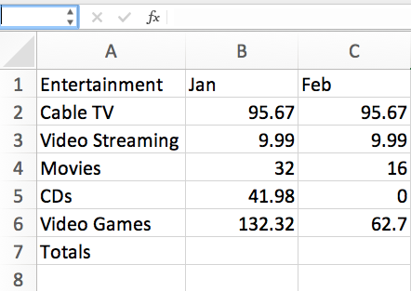

Now, working in the example spreadsheet, you will write formulas in cells to carry out certain functions.

Your first goal is to fill in the cells B7 and C7. Each of these cells is supposed to be the sum of the numbers in the cells above it. For example, B7 should be the sum total of the numbers in the cells B2 to B6. To achieve this result:

Click on cell B7. The cell should have its border highlighted.

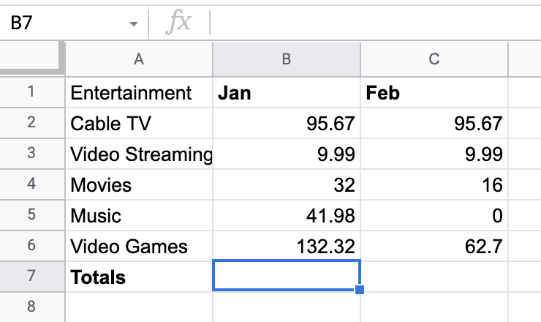

Column A:

A1 - Entertainment

A2 - Cable TV

A3 - Video streaming

A4 - Movies

A5 - Music

A6 - video games

A7 - Totals

Column B:

B1 - Jan

B2 - 95.67

B3 - 9.99

B4 - 32

B5 - 41.98

B6 - 132.32

Column C:

C1 - Feb

C2 - 95.67

C3 - 9.99

C4 - 16

C5 - 0

C6 - 62.7

2. With that cell selected, type =SUM(B2:B6) like in the figure below.

Notice that this command both shows up in the cell and the field above the table. This field is called the formula bar. Once you’ve clicked on a cell, typing in the formula bar is the same thing as typing directly into the cell.

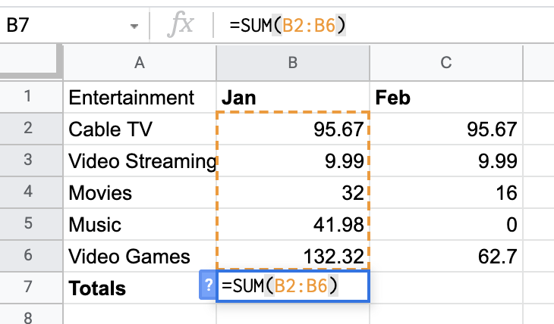

Column A:

A1 - Entertainment

A2 - Cable TV

A3 - Video streaming

A4 - Movies

A5 - Music

A6 - video games

A7 - Totals

Column B:

B1 - Jan

B2 - 95.67

B3 - 9.99

B4 - 32

B5 - 41.98

B6 - 132.32

B7: =SUM(B2:B6)

Column C:

C1 - Feb

C2 - 95.67

C3 - 9.99

C4 - 16

C5 - 0

C6 - 62.7

The argument of the SUM command is the expression B2:B6. This expression represents a range of values starting from the first cell in the range (B2) to the last cell in the range (B6). The word SUM instructs the spreadsheet to add up the values in that range of cells. This works similarly if you wish to add across the rows instead.

3. Press ENTER. The view below should result.

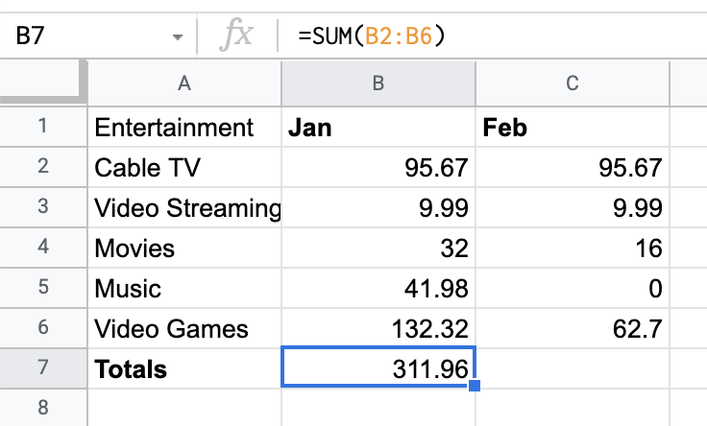

You will find that the SUM command in B7 is replaced by the numerical value (311.96) that is the sum of the numbers in cells B2 through B6 (if the value in cell B7 is not equal to 311.96 check the formula to ensure you have the correct range). The formula bar, however, still has the SUM command. This is to inform people reading the spreadsheet how the value in cell B7 was determined.

## Find errors in formulas



Syntax is very important for making proper formulas in spreadsheets. Explore what happens when you leave out a character or make an error.

1. Click on cell C7. Enter the SUM command SUM(C2:C6) either in the cell itself or the formula bar. Do NOT include the =. Hit ENTER. It should display the following:

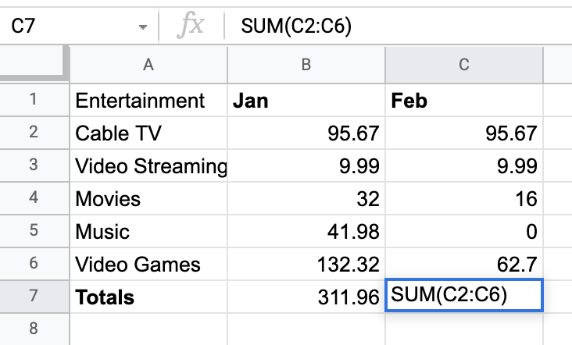

The equal sign in the SUM command is not optional. Without it, the spreadsheet will interpret the input as a string. A string is text data. For the formula to work, it needs numeric data. This is why the command is uncalculated in C7. When the equal sign is included, the spreadsheet knows to carry out the sum calculation and return the result in the cell.

2. Spreadsheets handle string data quite differently than numerical data. Column A of this table is populated entirely by string data—the labels for each row. Try to input the SUM command on this column. In cell A8, type =SUM(A2:A6) and hit ENTER.

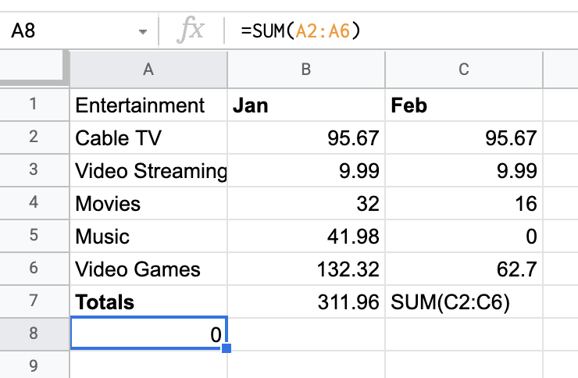

You will find the spreadsheet calculated zero for the sum. This is because the program was asked to sum strings. When a given cell contains a string, the program considers the numerical value of the cell as zero.

That's how the SUM command in Excel works. There are many other commands available to you beyond the SUM command. If you know the commands, you can enter them just like how you entered the SUM command.

## Confirmation and reflection



Question 1 - multiple choice, shuffle

How would you write a formula to calculate February’s entertainment expenses for Cable TV, Video Streaming, and Movies in the example spreadsheet?

1. **=SUM(C2:C4)**
2. **SUM(C2:C6)**
3. **=SUM(B2:C4)**
4. **SUM(B2:C6)**

Question 2

During this activity, you explored spreadsheet formulas and practiced writing them. In the text box below, write 2-3 sentences (40-60 words) in response to each of the following questions:

* When you wrote the incorrect formulas, what did you learn about spreadsheet data?
* How do you think this knowledge of the SUM spreadsheet formula will help you write other kinds of formulas?